**DAY 01 INTRODUCTION TO MACHINE LEARNING**

**HISTORY**

* The term Machine Learning was coined by Arthur Samuel in 1959, an American pioneer in the field of computer gaming and artificial intelligence
* He stated that “it gives computers the ability to learn without being explicitly programmed”.

**EXAMPLE**

* Suppose that you decide to check out that offer for a vacation . You browse through the travel agency website and search for a hotel.
* When you look at a specific hotel, just below the hotel description there is a section titled “You might also like these hotels”. Suggestions like “You may also like these hotels” common use case of Machine Learning called “Recommendation Engine”.

**OVERALL TYPES IN MACHINE LEARNING**

1. Supervised Learning
2. Unsupervised Learning
3. Reinforcement Learning
4. Semi Supervised Learning

Machine learning implementations are classified into three major categories, depending on the nature of the learning dataset which are as follows:-

1. **Supervised learning :**
   * When an algorithm learns from example data and associated target responses that can consist of numeric values or string labels, such as classes or tags, in order to later predict the correct response when posed with new examples comes under the category of Supervised learning.
   * This approach is indeed similar to human learning under the supervision of a teacher. The teacher provides good examples for the student to memorize, and the student then derives general rules from these specific examples.
   * **Example of Supervised Learning –** 
     + Practical example of supervised learning problems is predicting house prices. How is this achieved?

First, we need data about the houses: square footage, number of rooms, features, whether a house has a garden or not, and so on. We then need to know the prices of these houses, i.e. the corresponding labels. By leveraging data coming from thousands of houses, their features and prices, we can now train a supervised machine learning model to predict a new house’s price based on the examples observed by the model.

1. **Unsupervised learning :**
   * Whereas when an algorithm learns from plain examples without any associated response, leaving to the algorithm to determine the data patterns on its own.
   * This type of algorithm tends to restructure the data into something else, such as new features that may represent a class or a new series of un-correlated values.
   * They are quite useful in providing humans with insights into the meaning of data and new useful inputs to supervised machine learning algorithms.
   * **Example of Unsupervised Learning –** 
     + Practical example of unsupervised learning problems is finding customer segments.

Clustering is commonly used for determining customer segments in marketing data. Being able to determine different segments of customers helps marketing teams approach these customer segments in unique ways. (Think of features like gender, location, age, education, income bracket, and so on.)

1. **Reinforcement learning :**
   * When you present the algorithm with examples that lack labels, as in unsupervised learning.
   * However, you can accompany an example with positive or negative feedback according to the solution the algorithm proposes comes under the category of Reinforcement learning, which is connected to applications for which the algorithm must make decisions (so the product is prescriptive, not just descriptive, as in unsupervised learning), and the decisions bear consequences.
   * In the human world, it is just like learning by trial and error.Errors help you learn because they have a penalty added (cost, loss of time, regret, pain, and so on), teaching you that a certain course of action is less likely to succeed than others.
   * **Example of Reinforcement Learning -**
     + An interesting example of reinforcement learning occurs when computers learn to play video games by themselves. In this case, an application presents the algorithm with examples of specific situations, such as having the gamer stuck in a maze while avoiding an enemy.
2. **Semi-supervised learning :**
   * It is where an incomplete training signal is given, a training set with some (often many) of the target outputs missing.
   * **Example of Semi-Supervised Learning -**
     + **Speech Analysis:** Speech analysis is a classic example of the value of semi-supervised learning models. Labelling audio files typically is a very intensive tasks that requires a lot of human resources. Applying techniques can really help to improve traditional speech analytic models.

**OVERALL CATEGORISATION / OVERALL TYPE IN MACHINE LEARNING**

1. Classification
2. Regression
3. Clustering

Another categorization of machine learning tasks arises when one considers the desired output of a machine-learned system:

1. **Classification :** When inputs are divided **or classify** into two or more classes, and the learner must produce a model that assigns unseen inputs to one or more (multi-label classification) of these classes. This is typically tackled in a supervised way. Spam filtering is an example of Classification, where the inputs are email (or other) messages and the classes are “spam” and “not spam”.
2. **Regression :** Which is also a supervised problem, a case when the outputs are continuous rather than discrete. House Price is an example of Regression, where House Price / Target Variable is Continuous.
3. **Clustering :** When a set of inputs is to be divided into groups. Unlike in classification, the groups are not known beforehand, making this typically an unsupervised task. Customer Segmentation is an example of Clustering.

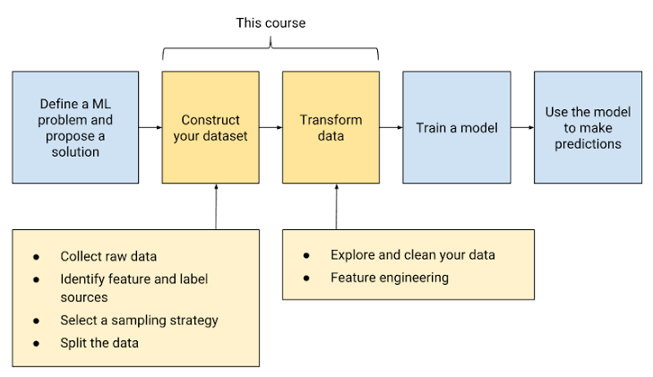**MACHINE LEARNING OVERALL WORKFLOW**